**EMPLOYEE ATTRITION ANALYSIS PROJECT**

**Project Title**: Employee Attrition Analysis

**Prepared for**: Human Resources Department

**Prepared by**: Qurate Analytics

**Purpose**: To analyze employee attrition patterns and provide actionable insights to reduce turnover

**Date**: August 2025

**Software for Analysis:** Microsoft Power Bi

**Project Overview**

The company is currently experiencing a significant attrition rate, with both current and former employee data indicating patterns of staff turnover. The Human Resources department is preparing for an executive meeting to address this issue and requires in-depth analytics to uncover the underlying reasons behind employee exits.

This project, led by Qurate Analytics, aims to provide a comprehensive analysis of attrition trends across departments, job roles, income brackets, job satisfaction levels, and work-life balance indicators. By examining these key factors, the project will identify the primary drivers of attrition and recommend actionable strategies to improve employee retention.

**Objective of the Analysis**

The objective of this analysis is to examine employee attrition patterns within the organization using the given staff details and by identifying key factors such as income levels, job satisfaction, and work-life balance, the goal is to uncover the primary drivers of employee attrition and provide actionable insights that can support HR in designing effective retention strategies and improving workforce stability.

**Problem Statement**

The company is currently experiencing a relatively high attrition rate, which poses a threat to organizational performance and operational efficiency. While employees are leaving across multiple departments and roles, the root causes and high-risk groups are not fully understood. This gap in understanding makes it difficult to retain critical talent, and control the rising costs of recruitment, training, and lost productivity.

**METHODOLOGY**

1. **Data Collection:**

* **Source**: Employee dataset (200 records × 16 columns) from HR Department.
* **Key Fields:** Attrition, Department, Job Role, Monthly Income, Years at Company, Work-Life Balance, Job Satisfaction, Over time.
* Timeframe: Point-in-time snapshot (no temporal sequence).

1. **Data Cleaning and Preprocessing** 
   * Standardized column names.
   * Converted Attrition field to binary (Yes=1, No=0).
   * Created additional columns for analysis:
     + Income Band – To determine the level of satisfaction of workers with the salary.
     + Age Band (18–25, 26–35, 36–45, 46–55, 56+)
   * Created Measures for expository analysis, to understand the company metrics.
   * No **missing values**, no duplicate and Inconsistencies were corrected.
2. **Data Exploration**

* **Overall Attrition Rate**: A measure was created to calculate the overall attrition rate in the company using the formular.

Attrition Rate (%) = $\frac{Employees who left }{ Headcount}×100$

The results was 24%

Other Key Performance Metrics was taken as well which is available of the chart.

**4. Data Exploration (Exploratory Data Analysis - EDA)**

* **Employee Attrition**:
  + Calculate attrition rate by department and Job roles.
  + Plot age band, salary band and other key metrics vs. attrition.
  + Check the salary range between staff.
  + Encoding of the Attrition table to YES to 1 and NO to 2.

1. **Data Visualization and Insights**

Key Performance Metric Dashboard

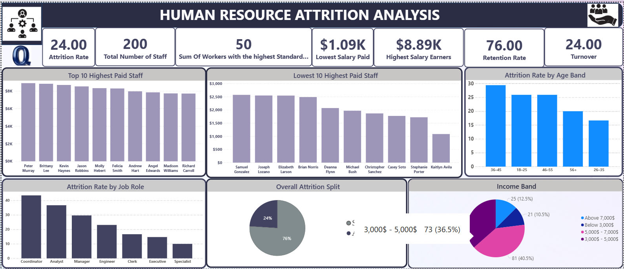

Attrition Analysis

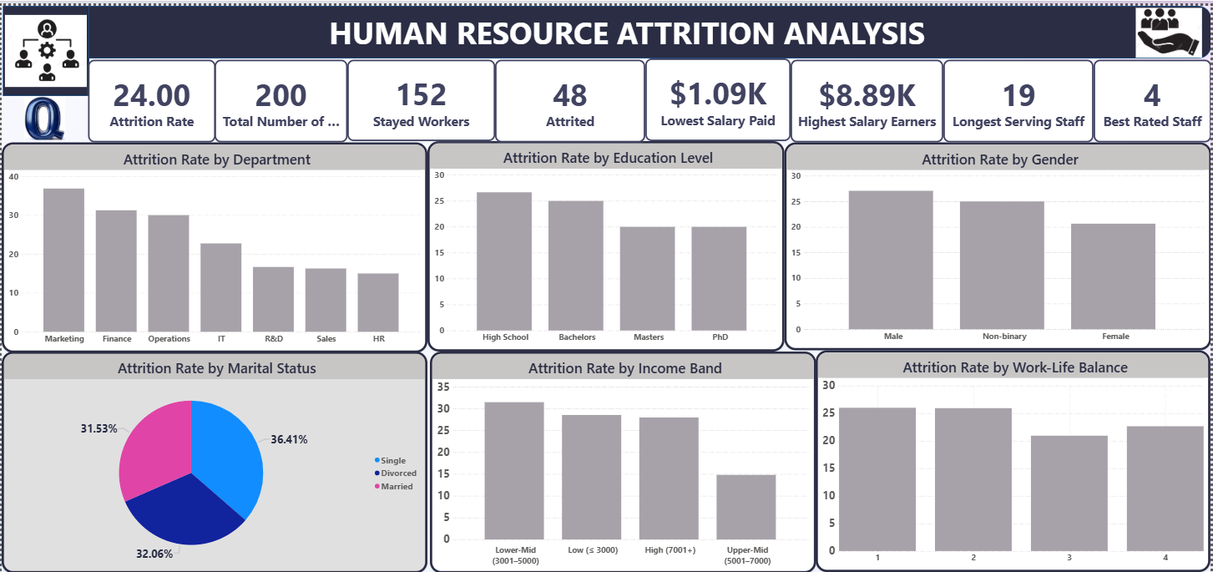

**INSIGHTS AND ANALYSIS**

**Human Resource Attrition Analysis Summary**

**Overall Stats:**

Attrition Rate: 24%,

Total Staff: 200,

Sum Workers with the Highest Rating: 50,

Lowest Salary: $1.09K,

Highest Salary: $8.89K,

Retention Rate: 76%,

Turnover: 24%

Attrited: 48

Stayed Workers: 152

**Key Findings and Observation**

**Departmental Risks**

* Marketing (36.84%), Finance (31.25%), and Operations (30.0%) record the highest attrition rates and seems to be the more stressful department.

**Role Vulnerability**

* Coordinators (43.48%), Analysts (36.67%), and Managers (29.63%) are the most exit-prone job roles.

**Compensation Bands**

* Lowest income quartile ($3,000–$5,000) shows 31.51% attrition, confirming pay competitiveness as a driver for staff retention.

**Work-Life Balance**

* Employees with low WLB (rating=1 and 2): 26.0% and 25.93% attrition rate.

**Age Bracket:**

* People from the age of 36-45 had the highest attrition rate of 29.41% and people from the age of 26 – 35 had the lowest attrition rate of 16.67%.

**Demographics:**

* **Marital Status:** The Level of attrition between singles, married and divorced seems to be evenly distributed but Singles has the highest attrition rate of 36.41%.
* **Gender:** The Male gender has the highest attrition rate of 27.08% slightly above the non-binary genders which is 25.00%.
* **Educational Level:** The young school leavers are most prone to attrition with 26.67%.

**Recommendations**

1. **Targeted Retention Programs**

* Prioritize interventions in Marketing, Finance, and Operations.
* Redesign Coordinator/Analyst roles with workload adjustments.

1. **Strengthen Onboarding & Early Engagement**

* Structured 30/60/90-day onboarding plan for new employees because the tend to leave the most.
* Conduct stay interviews for employees within the first year.

1. **Compensation Adjustments**

* Review salaries in the lowest quartile to align with market rates.
* Provide retention incentives for critical roles.

1. **Work-Life Balance & Job Satisfaction Improvements**

* Introduce flex scheduling and enforce overtime limits.
* Equip managers with recognition and engagement toolkits.
* Focus on employing suitable candidate within the age range of 25 – 36 years of age.
* For the demographics more attention need to paid to important factors like the marital status and educational qualification as well as the gender in most cases.

**Conclusion**

This analysis reveals that attrition is more likely to occur in specific department, among singles, and lowest income earners individual. This calls for more attention to these areas and more incentives should be provided for department with more attrition so as to boast the level of retention and also the recruitment process should be examined and adjusted to filter candidate with less enthusiasm to work and stay and also more attention needs to be paid to the amount of salary paid to workers.